**FOUNDATION UNIVERSITY ISLAMABAD**

**SCHOOL OF SCIENCE AND TECHNOLOGY**

**ASSIGNMENT NO 2**

**NAME:** ALISHBA HAFEEZ

**SUBJECT:** PF(LAB)

**SECTION:** 25 (B)

**DEPARTMENT:** BS IET

**INSTRUCTOR:** Mr. GHAZIF ADEEM

**ROLL NO:** 1025234338

**LAB 3 – C++ BUILDING BLOCKS –II**

**TASKS**

**ASCII Values in C++**

**TASK 3.1:**

Every character has an ASCII value. Write a C++ program that takes a single character as input from the user, calculates its ASCII code, and then displays the character along with its corresponding ASCII code. The ASCII Table is given above for your reference. Indent your code and include comments for improving the readability of your code. Your program should have the following interface.

**CODE:**

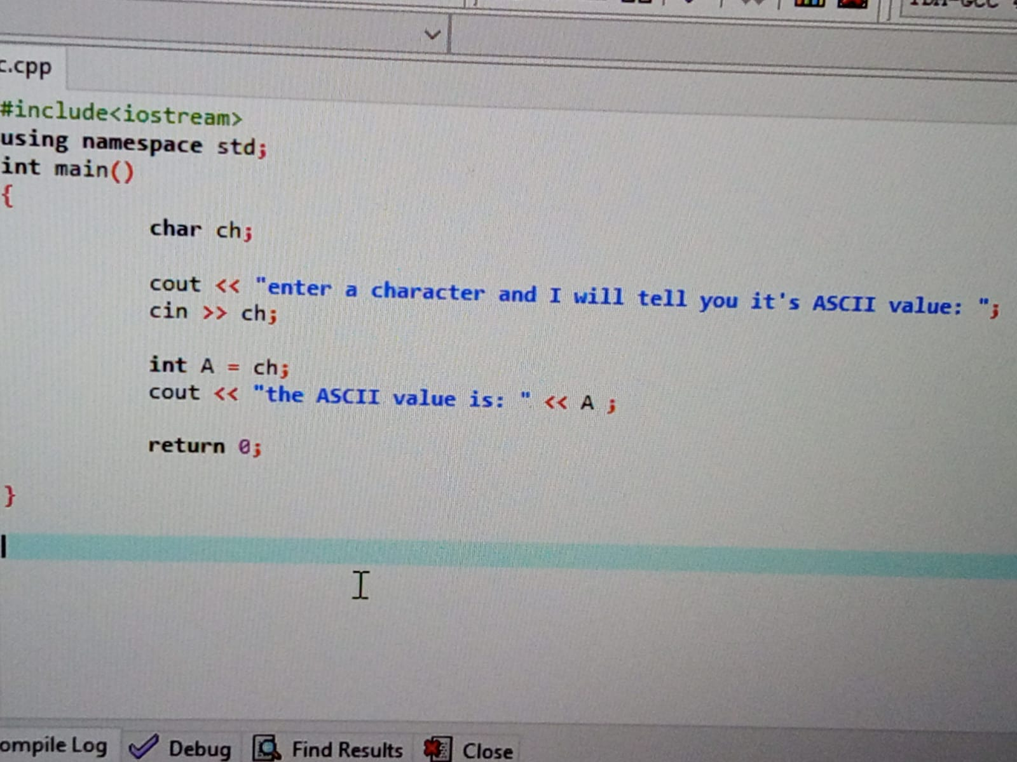

**OUTPUT:**

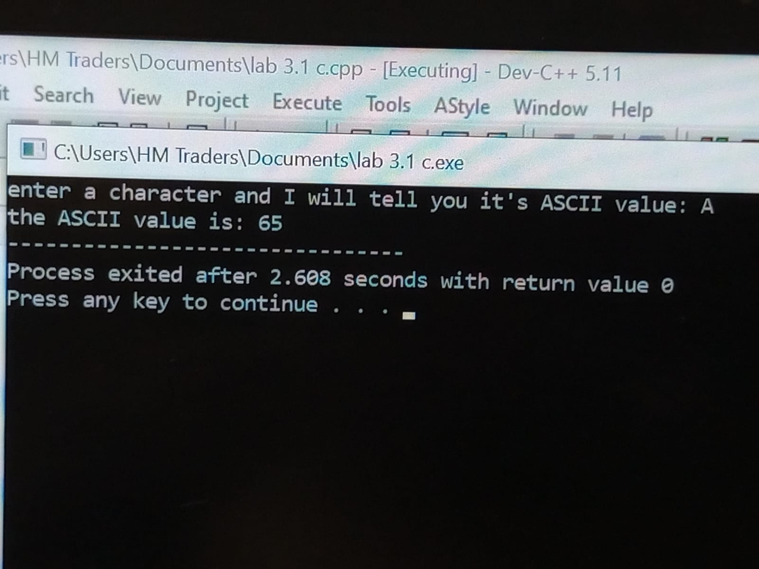

**TASK 3.2:**

Write a C++ program that takes an integer input in the range of 0 to 127 as an ASCII code from the user. The program should then convert this ASCII code into the corresponding character and display it on the screen.

**CODE:**

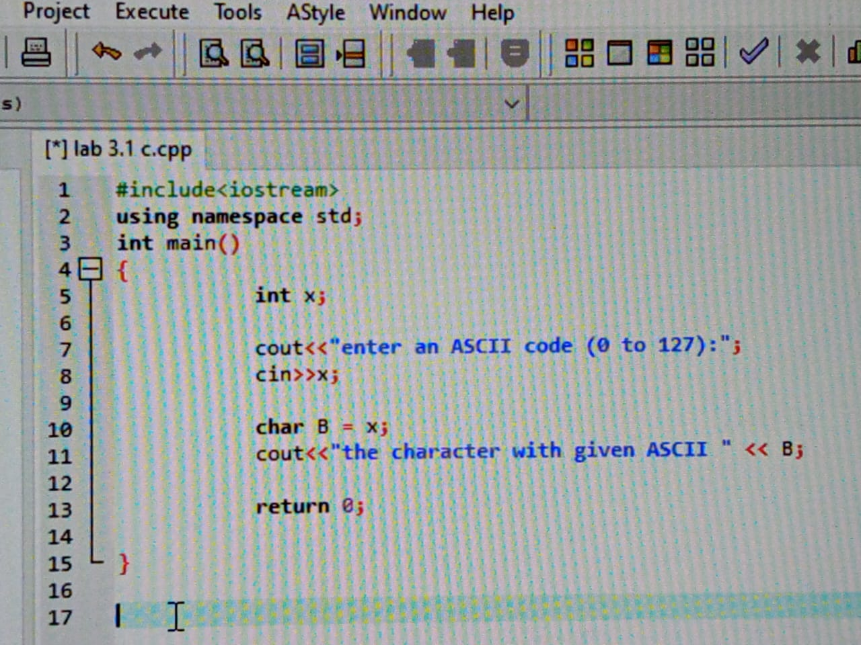

**OUTPUT:**

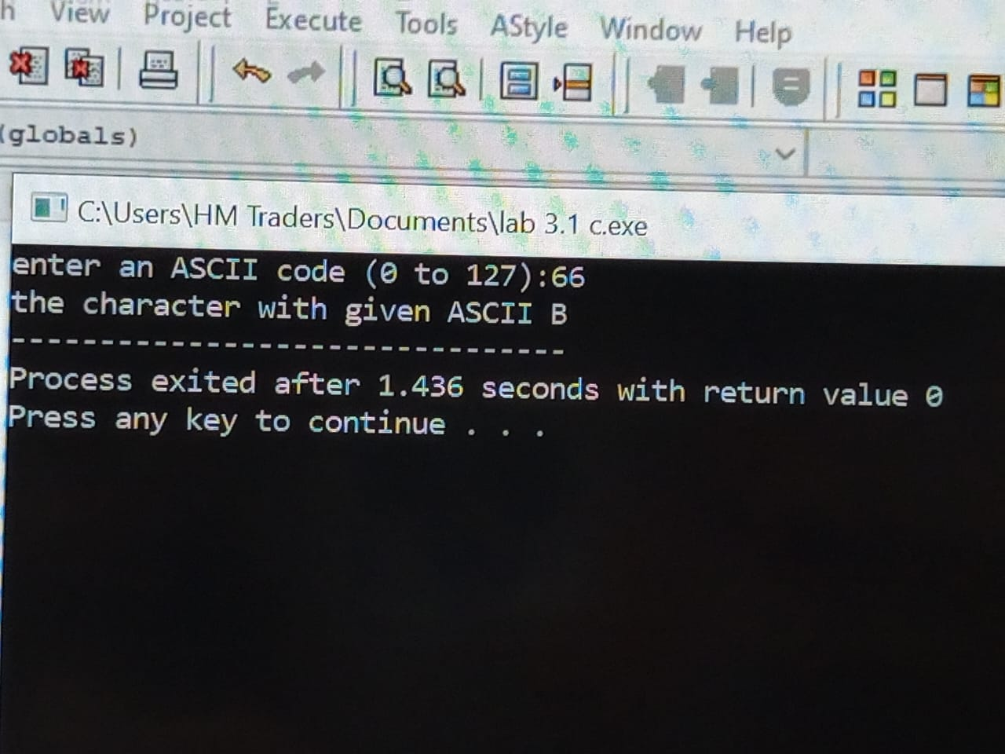

**TASK 3.3:**

Write a C++ program, which takes a character input from the user and prints its ASCII value on the screen. You must use all built-in functions for taking character input from the user (like getch(), getche(), getchar() etc.) one by one. ASCII Table is included in Appendix A for your reference. Indent your code and include comments for improving the readability of your code. Your program should have the following interface.

**CODE:**

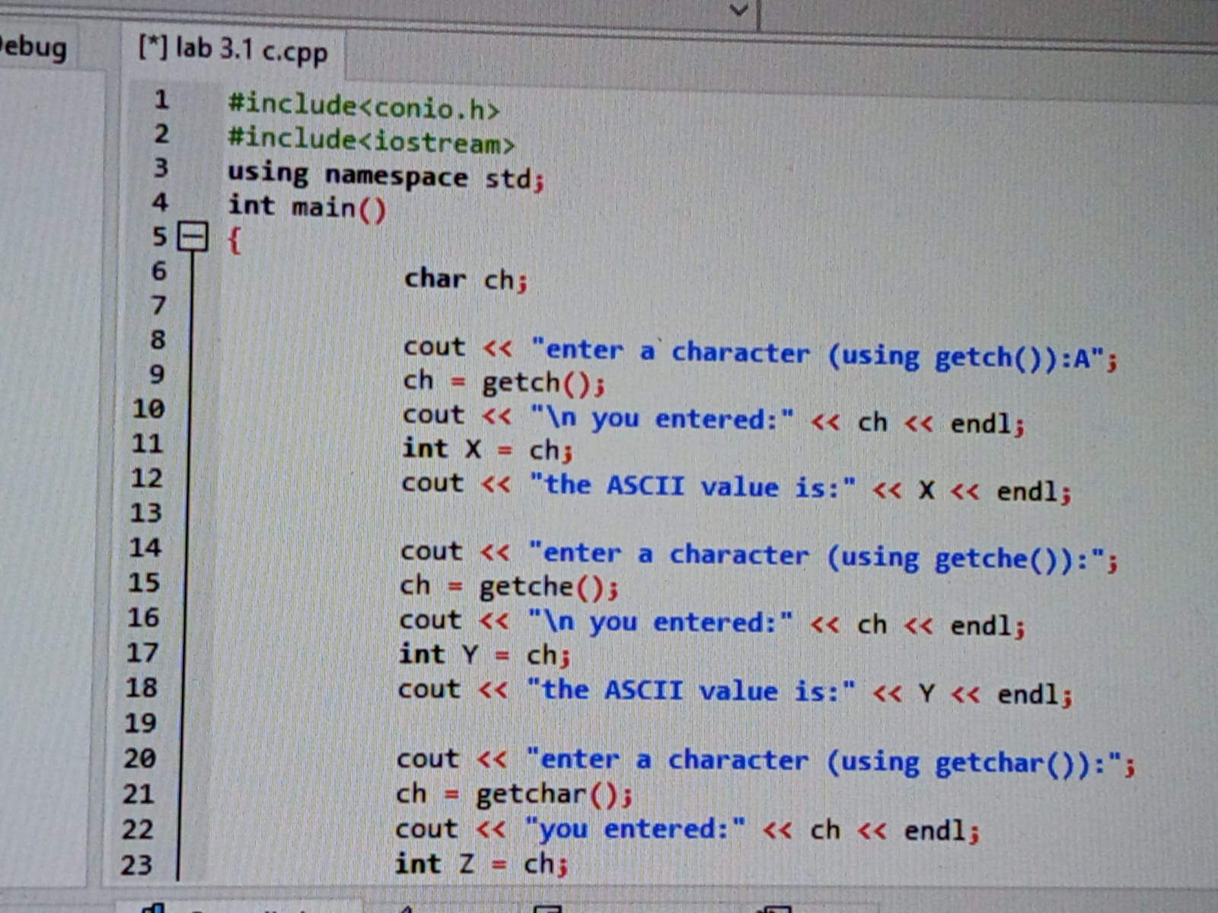

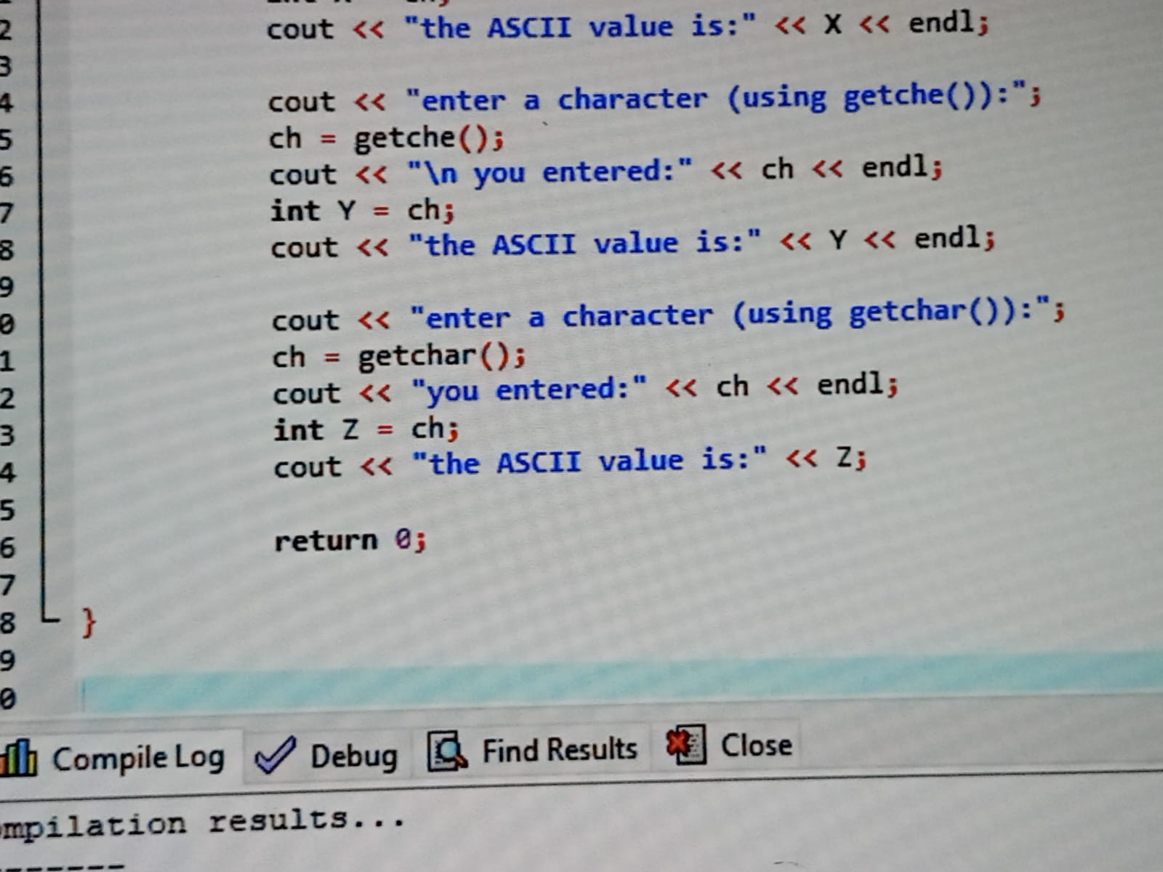

**OUTPUT:**

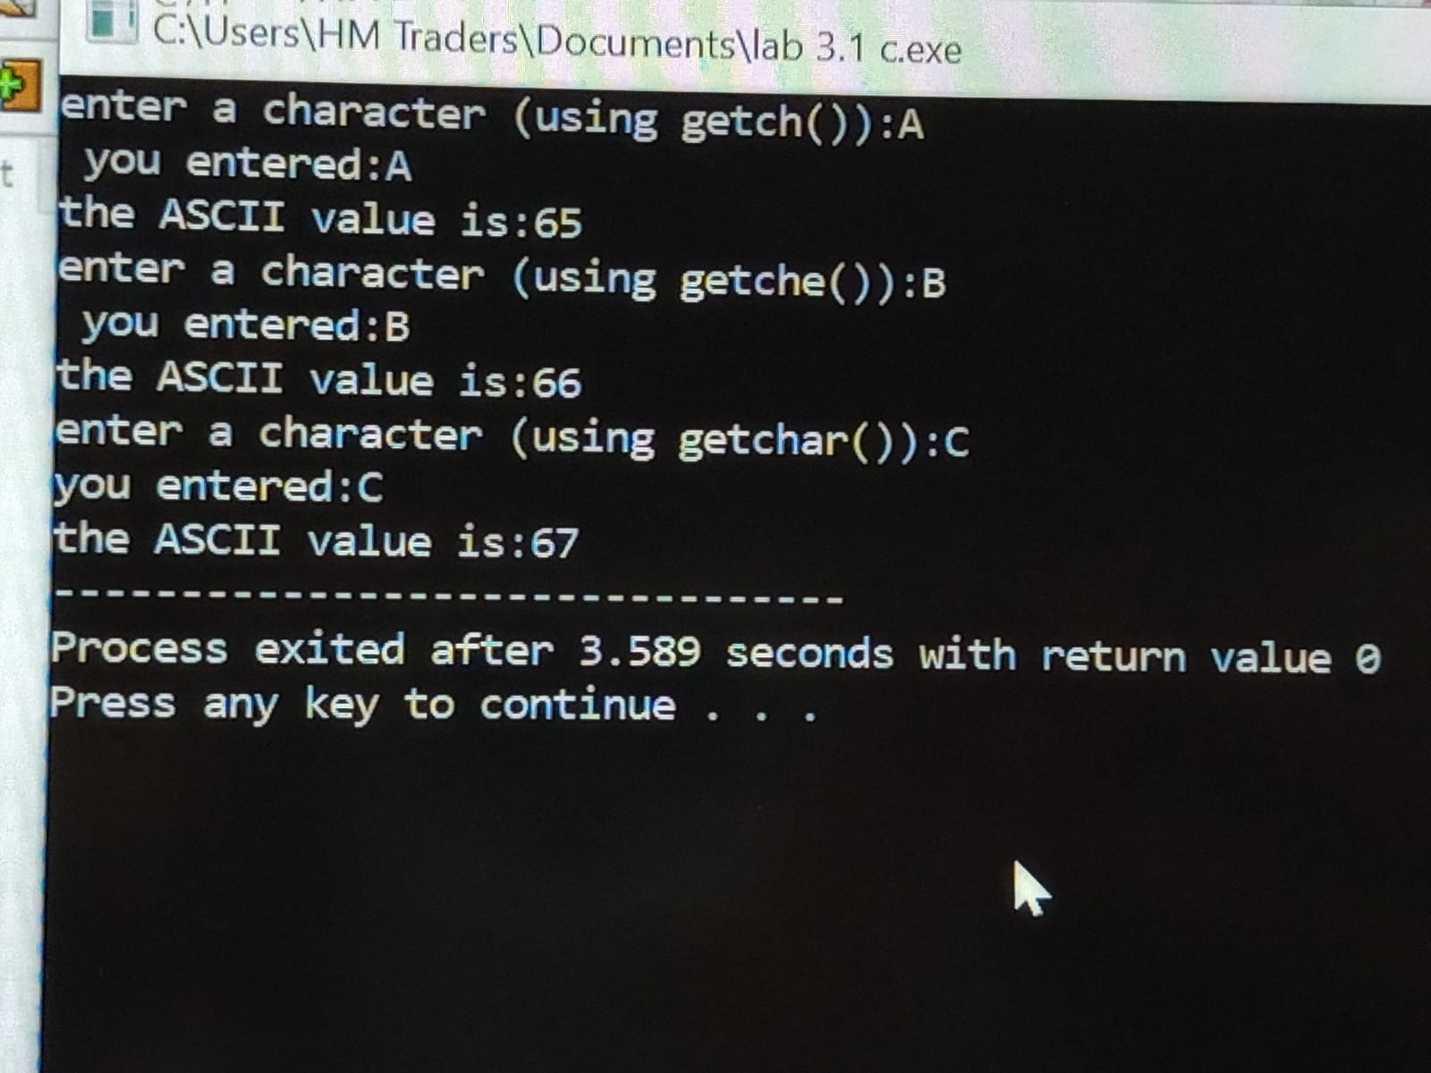

**TASK 3.4:**

Write a C++ program that takes three characters one by one as input from the user, calculates its ASCII codes, and then displays the sum of all ASCII codes.

**CODE:**

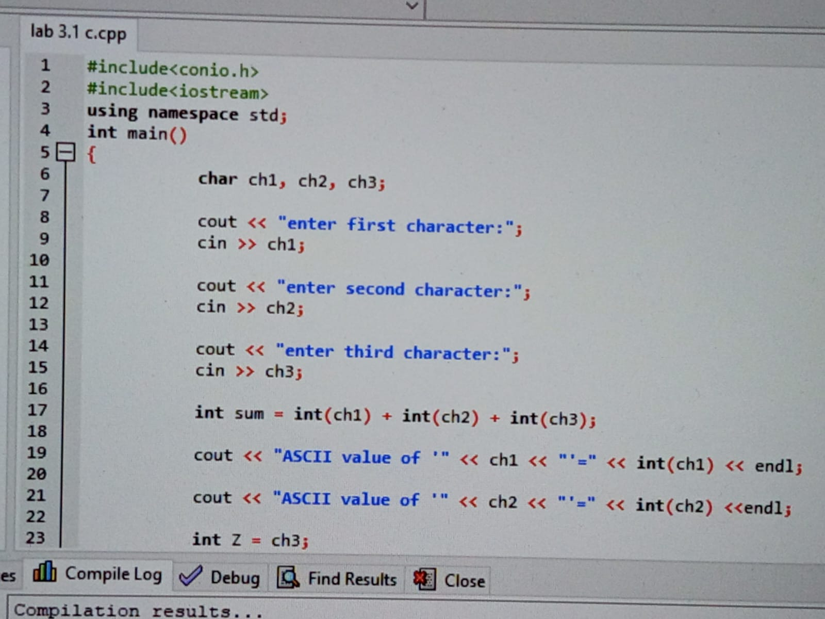

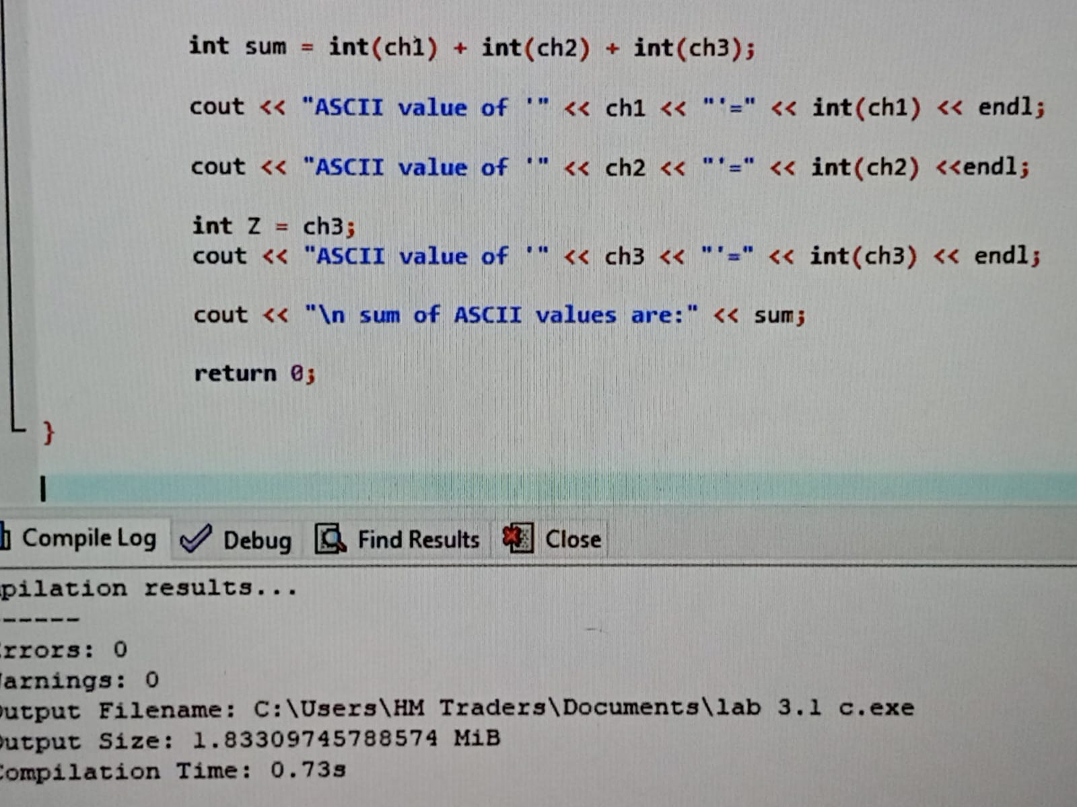

**OUTPUT:**

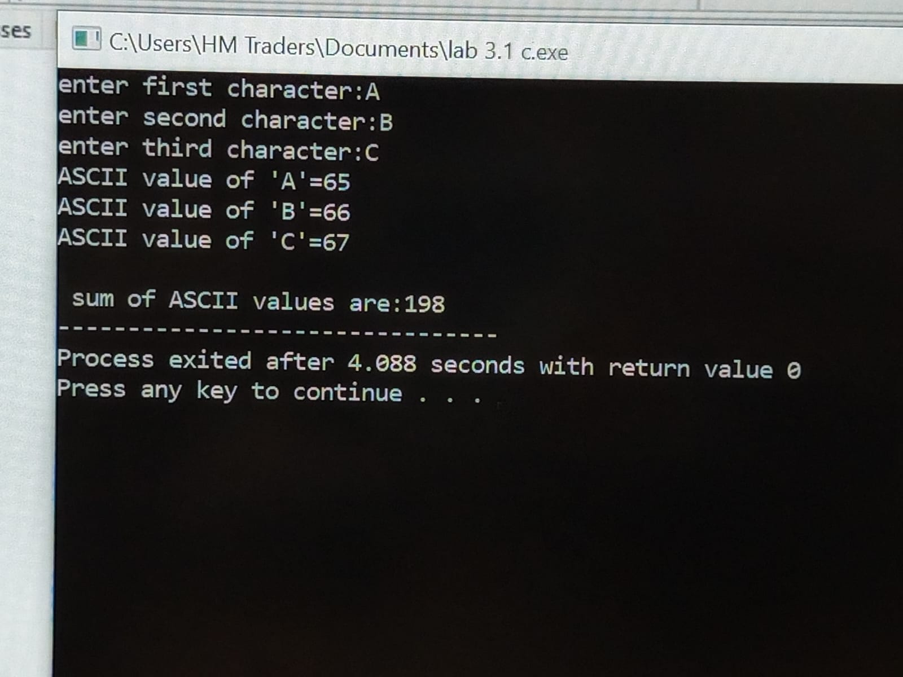

**TASK 3.5:**

Write a C++ program that takes two integer values, x, and y, as input from the user. The program should then perform several comparisons between these two values and display the results using Boolean variables (1 for true statement and 0 for false statement). Specifically, it should check if x is equal to y, greater than y, less than y, greater than or equal to y, and less than or equal to y.

**CODE:**

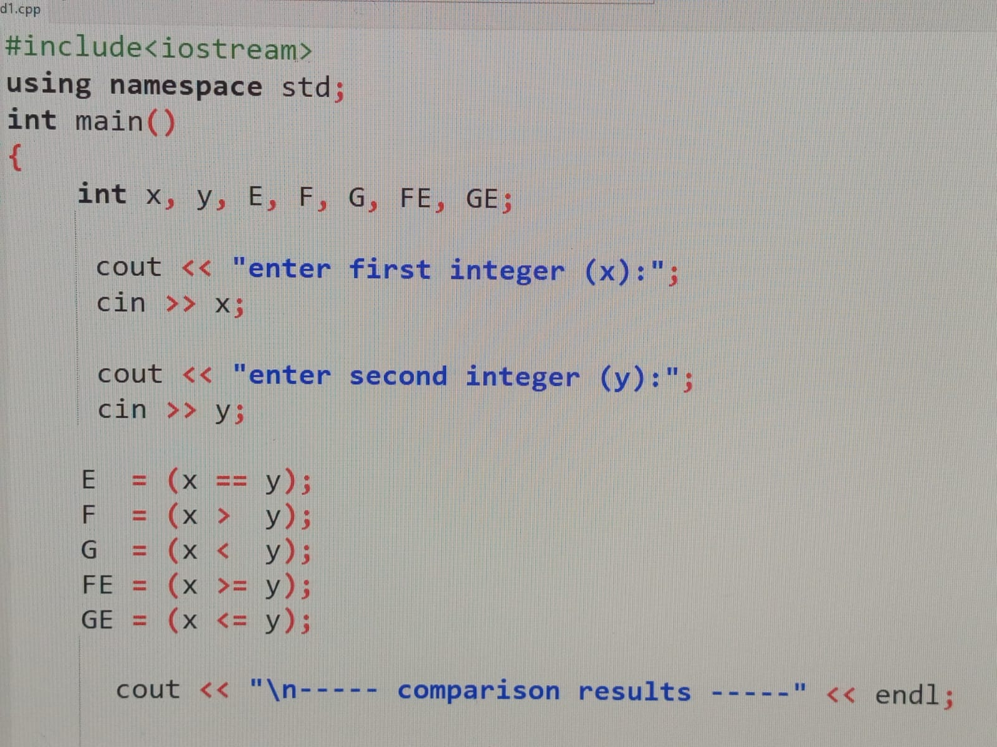

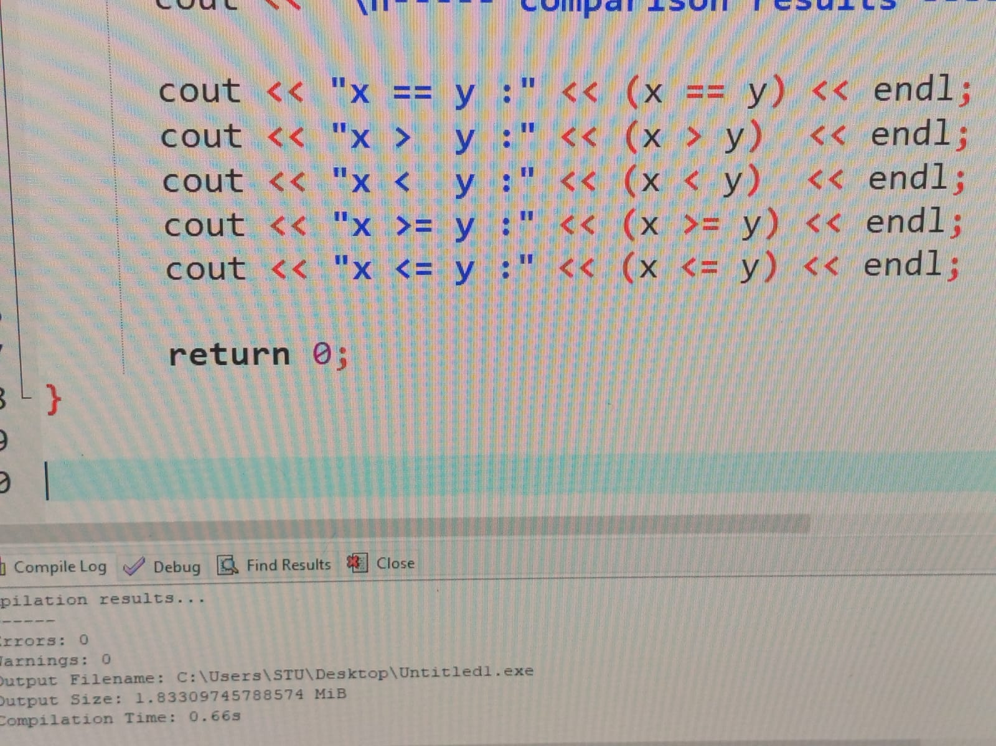

**OUTPUT:**

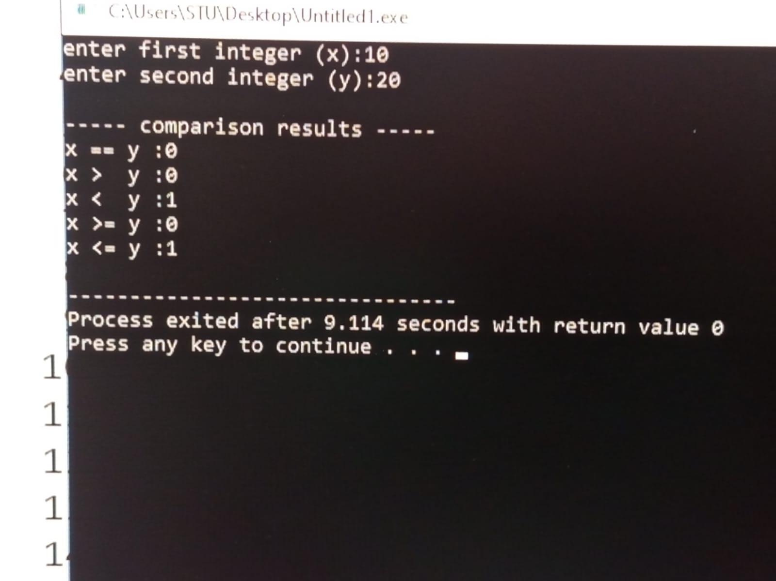

**TASK 3.6:**

Write a C++ program that takes temperature as input from the user. The program should display the results using logical operators (1 for bearable and 0 for unbearable).

**CODE:**

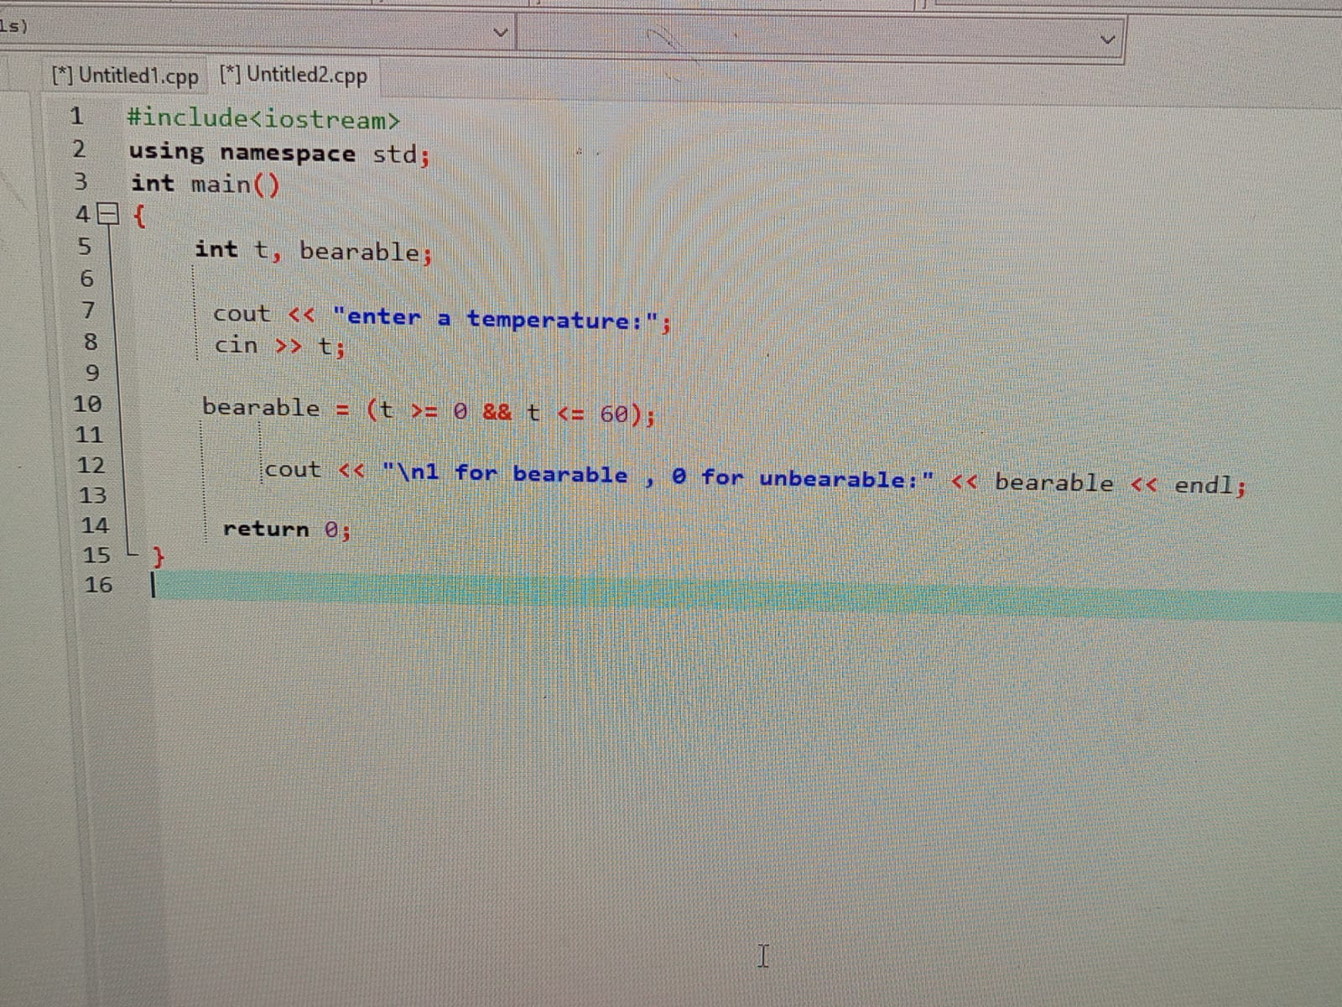

**OUTPUT:**

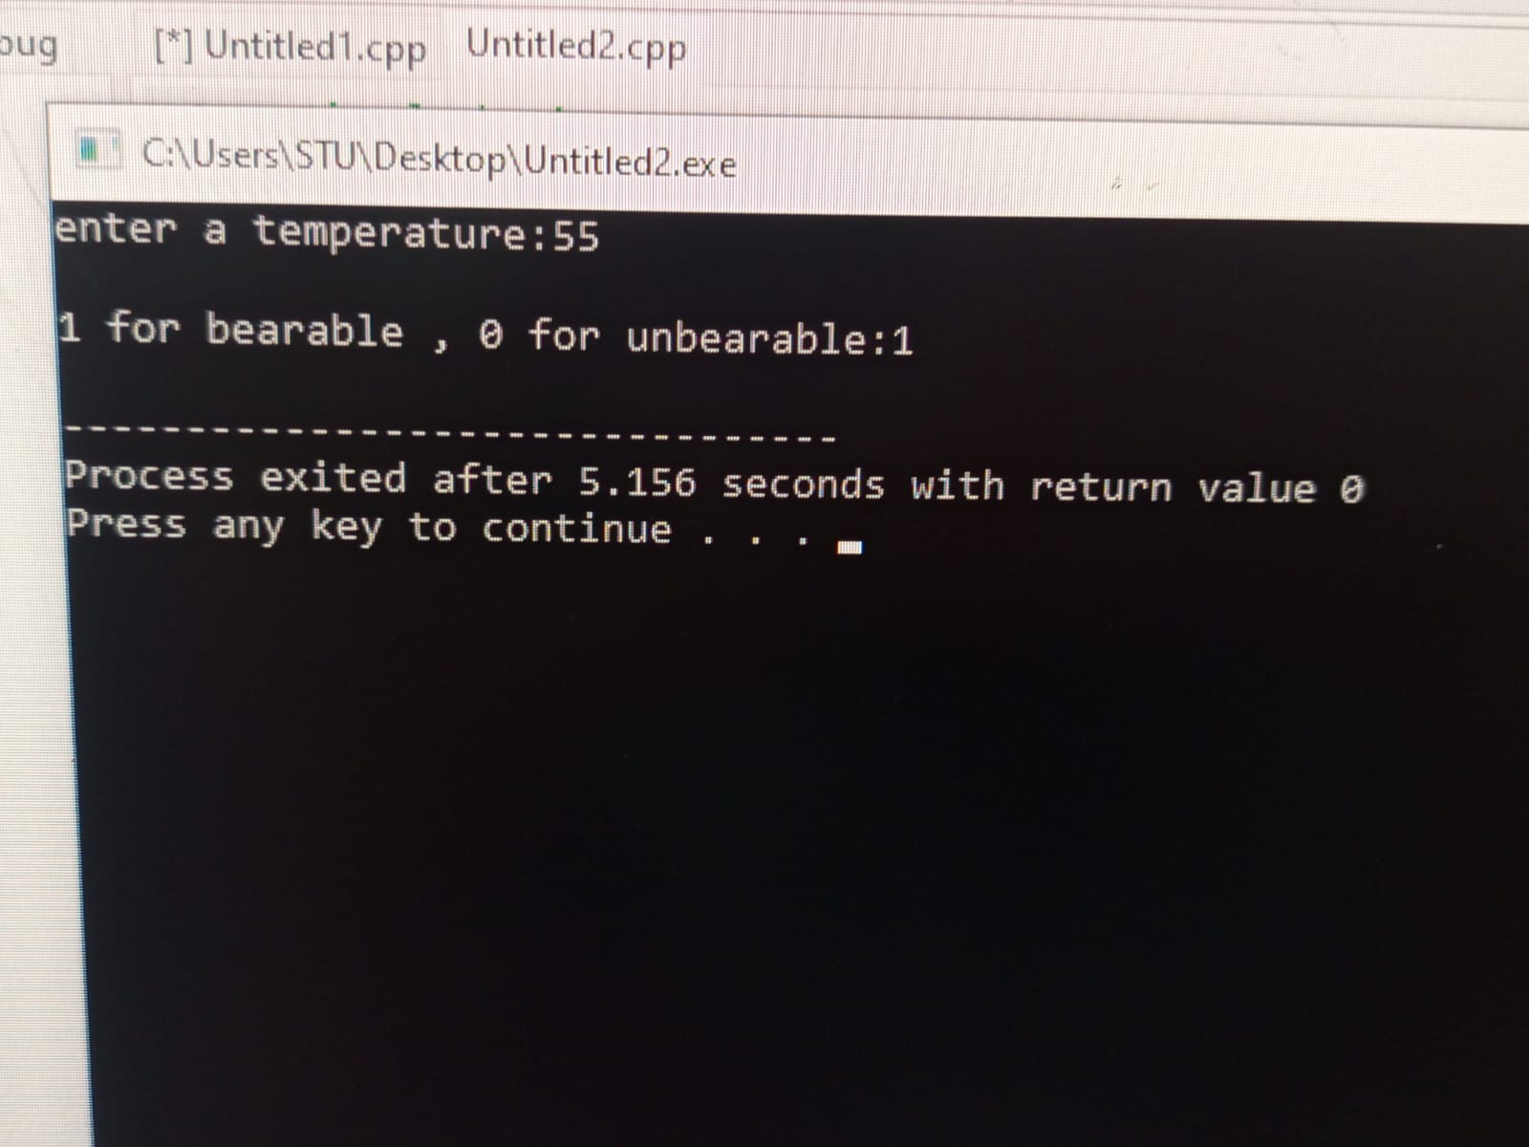

**TASK 3.7:**

Write a C++ program to determine if a customer is eligible for a discount or not (Display 1 if eligible and 0 if not eligible) by checking if the age of the customer is above 50 OR if their total purchase amount exceeds a certain 20,000 PKR.

**CODE:**

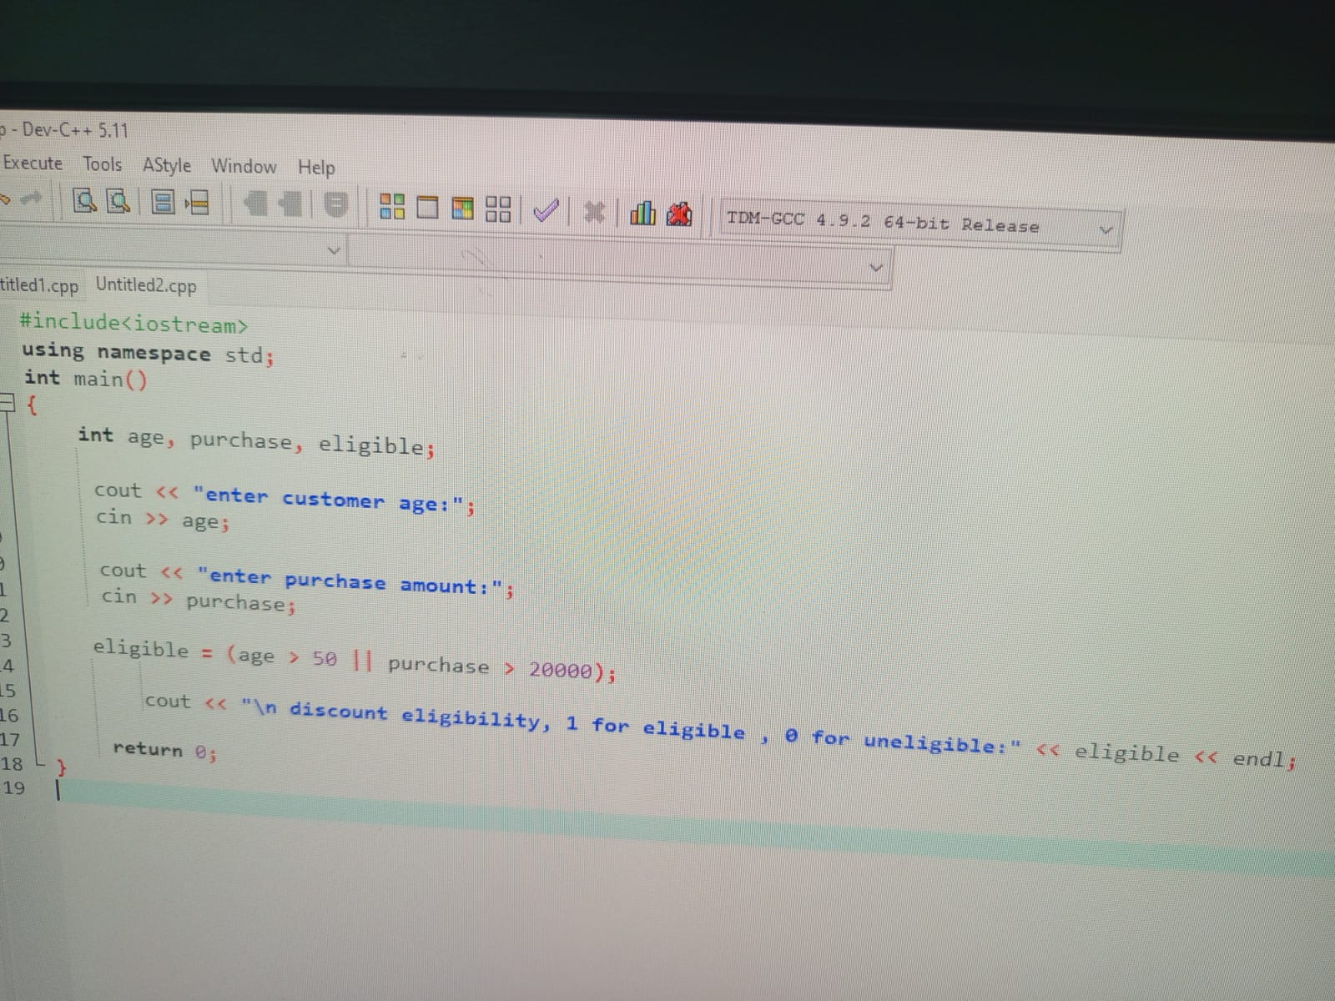

**OUTPUT:**

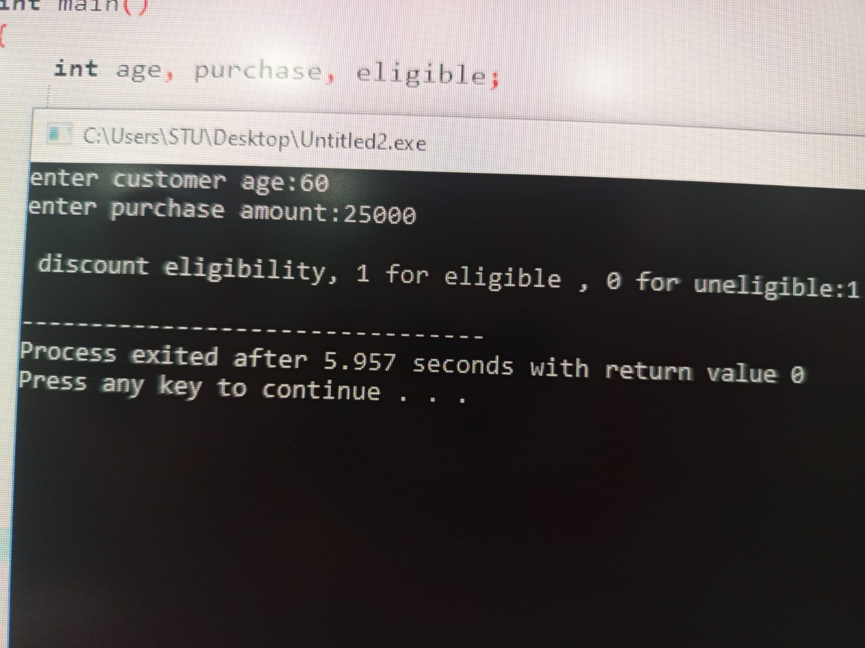

**TASK 3.8:**

Write a C++ program that takes 4 integer values, a, b, c, and d, as input from the user and calculates the output according to the given expressions

1. a + b * c / d =?

2. (a + b) * c / d =?

3. ((a + b) * c) / d =?

4. (a + b) * (c / d) =?

5. a + (b * c) / d =?

**CODE:**

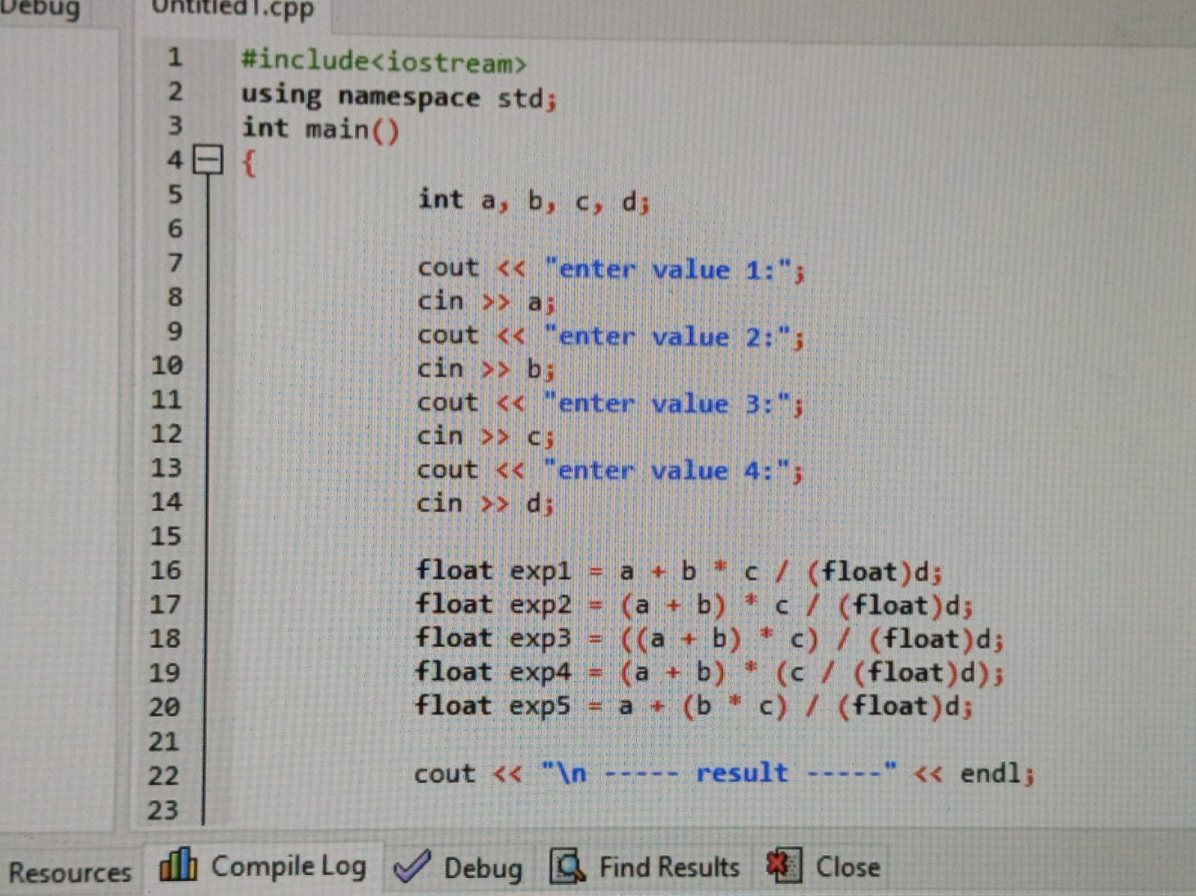

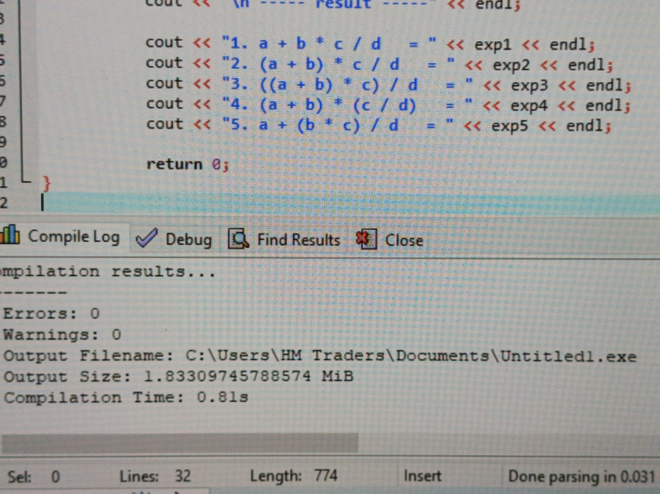

**OUTPUT:**

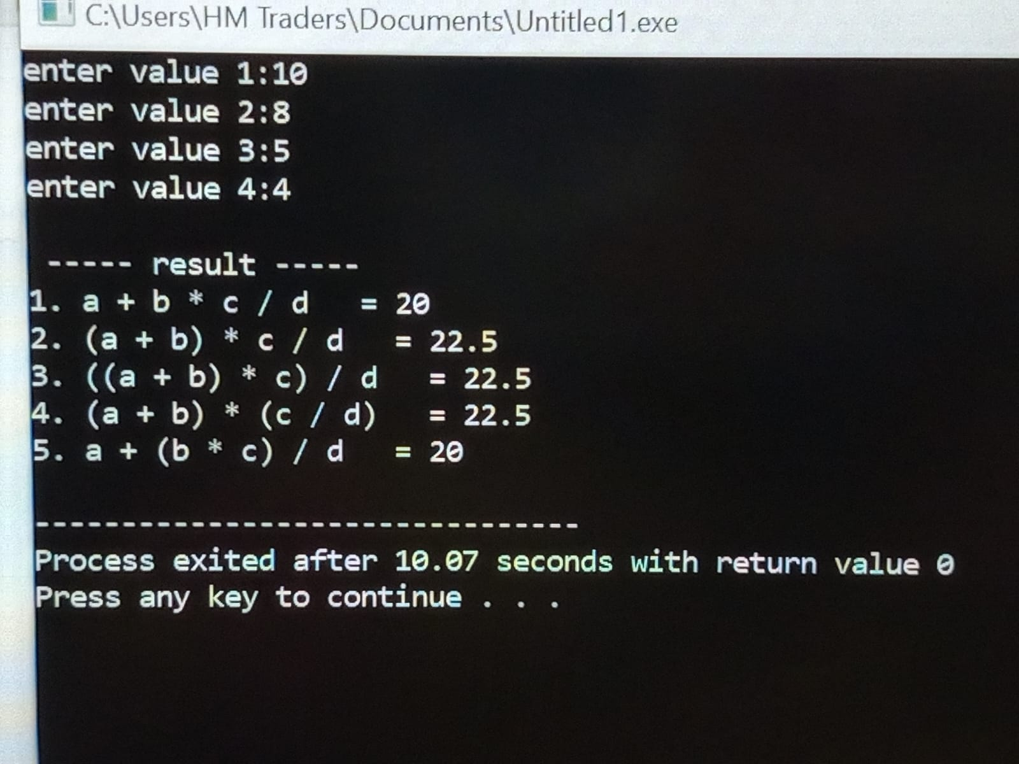

**EXERCISE**

**QUESTION 3.1:**

Write a C++ program that reads a three-digit number from the user and separates its digits. The output of your program should be as below. Indent your code and include comments for improving the readability of your code.

**CODE:**

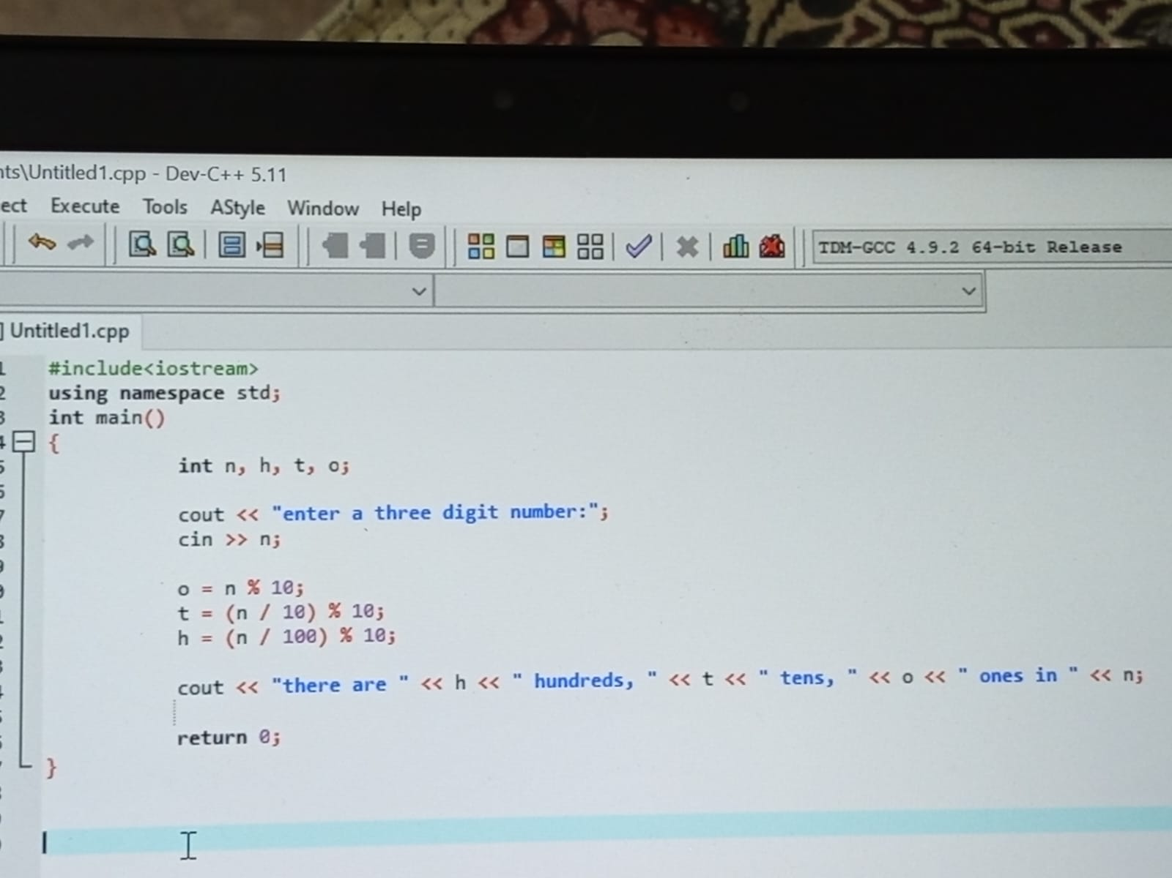

**OUTPUT:**

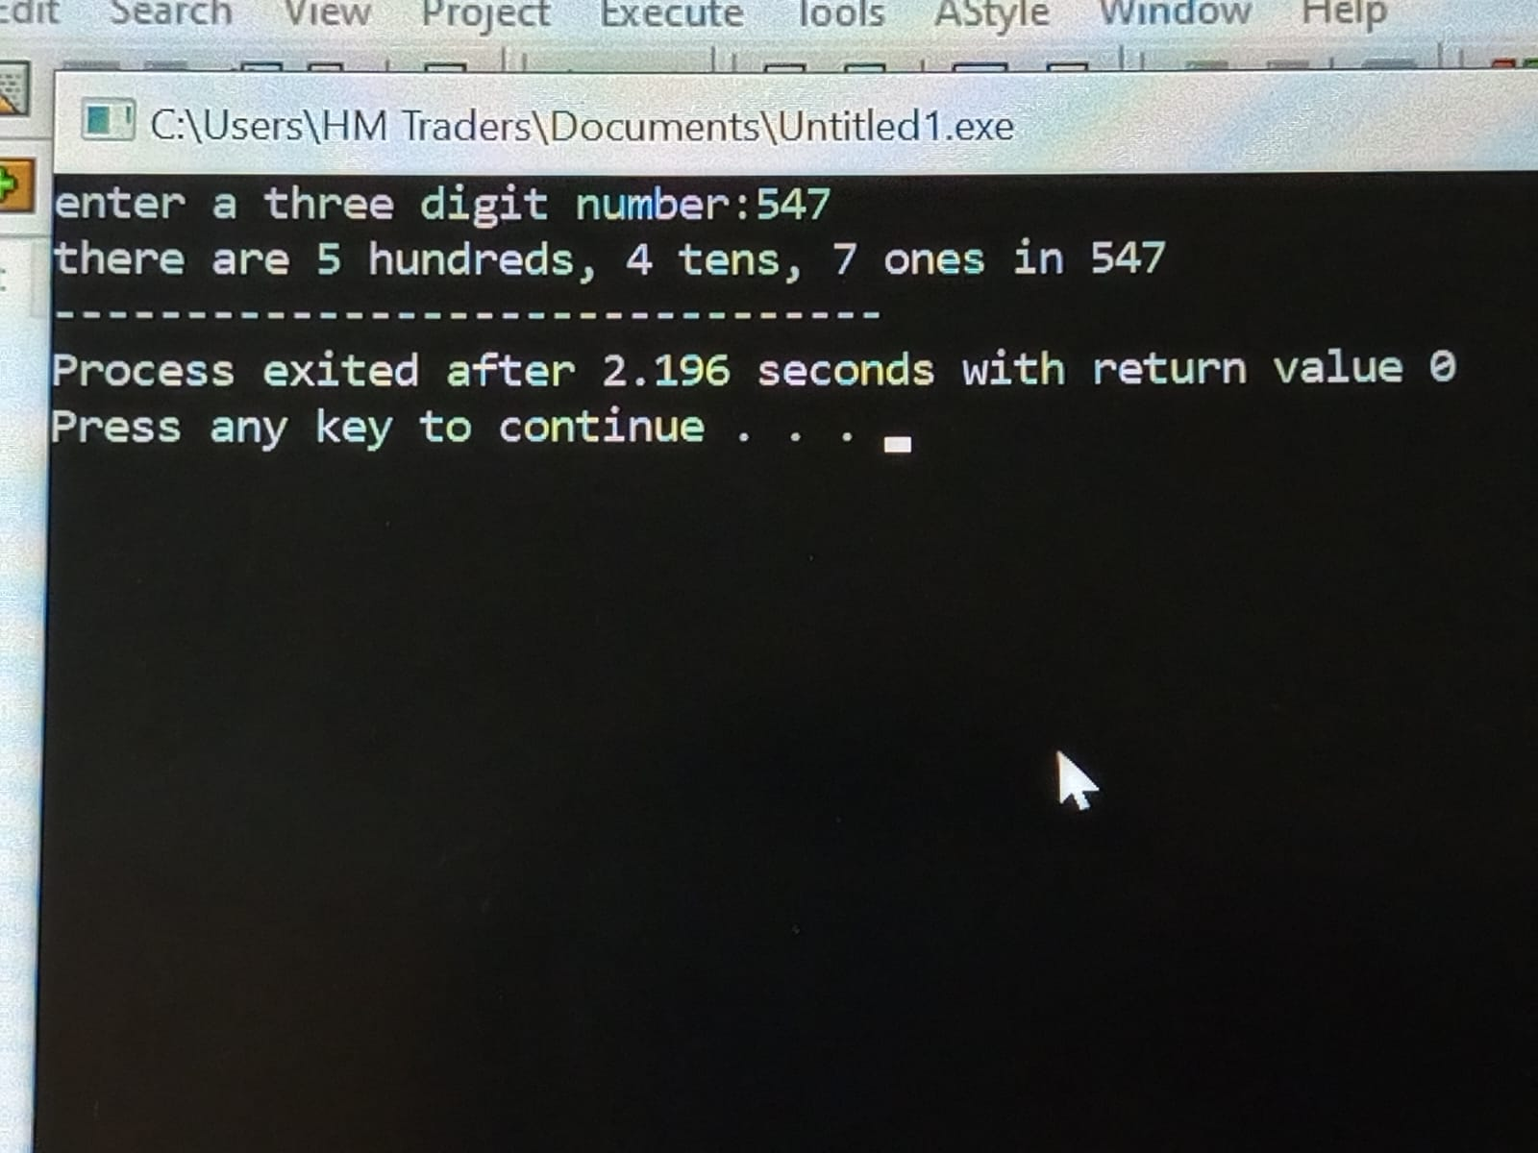

**QUESTION 3.2:**

Write a C++ program that prompts the user to enter two integer values, stores them in variables named ‘a’ and ‘b’, calculates the following expressions, and displays the results on the screen. The output of your program must be presentable. You must use the minimum possible number of parentheses for evaluating these expressions.

1. (a + b)2= a2 + 2ab + b2

2. (a - b)2 = a2 - 2ab + b2

**CODE:**

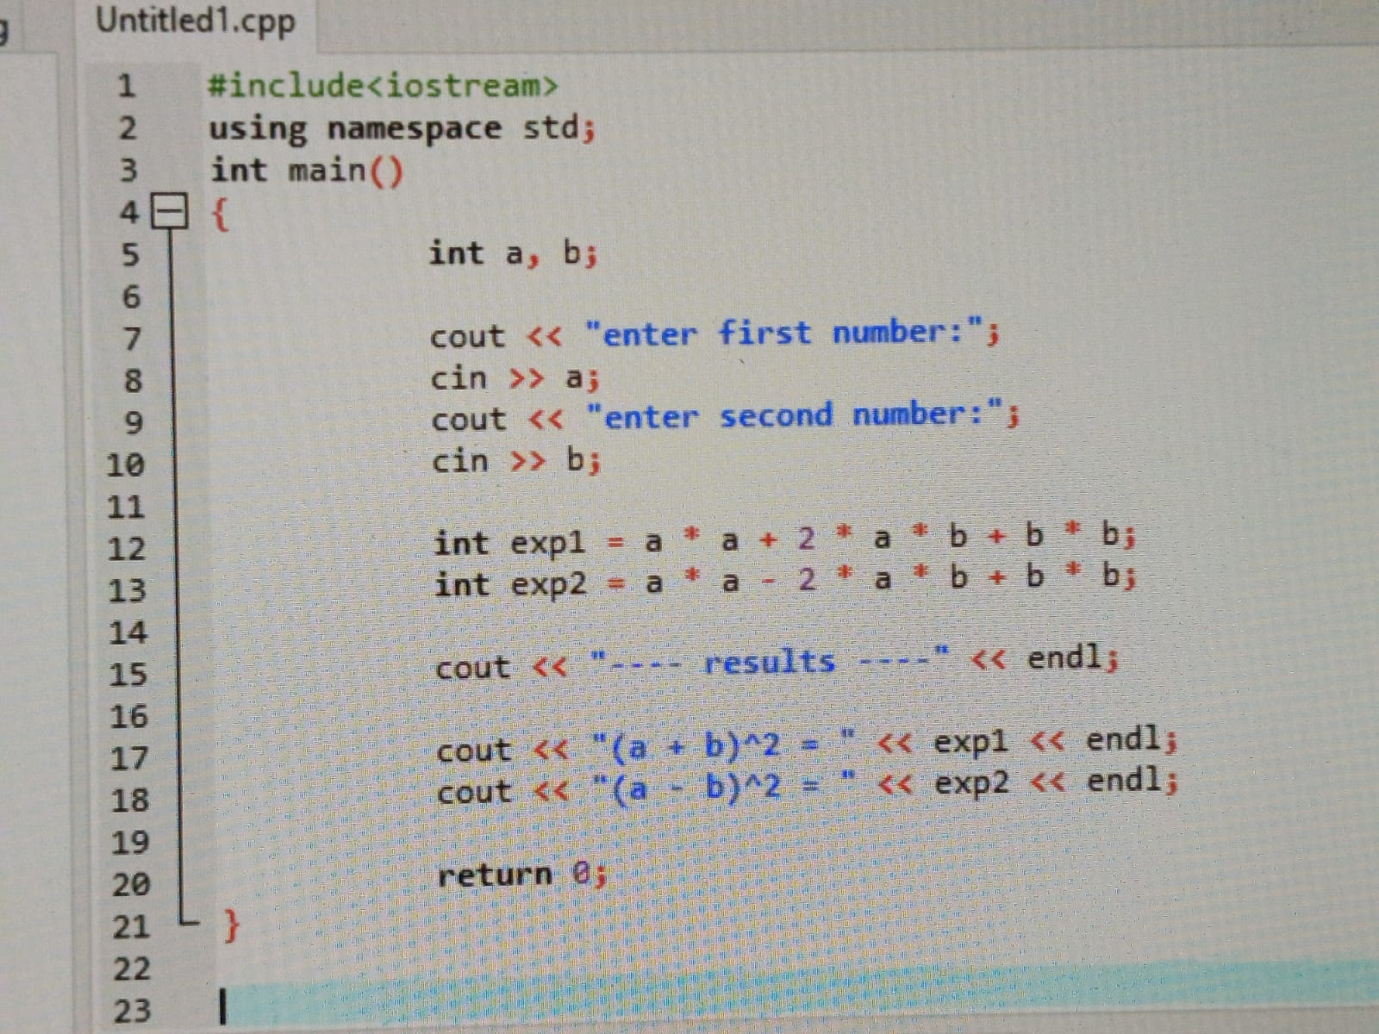

**OUTPUT:**

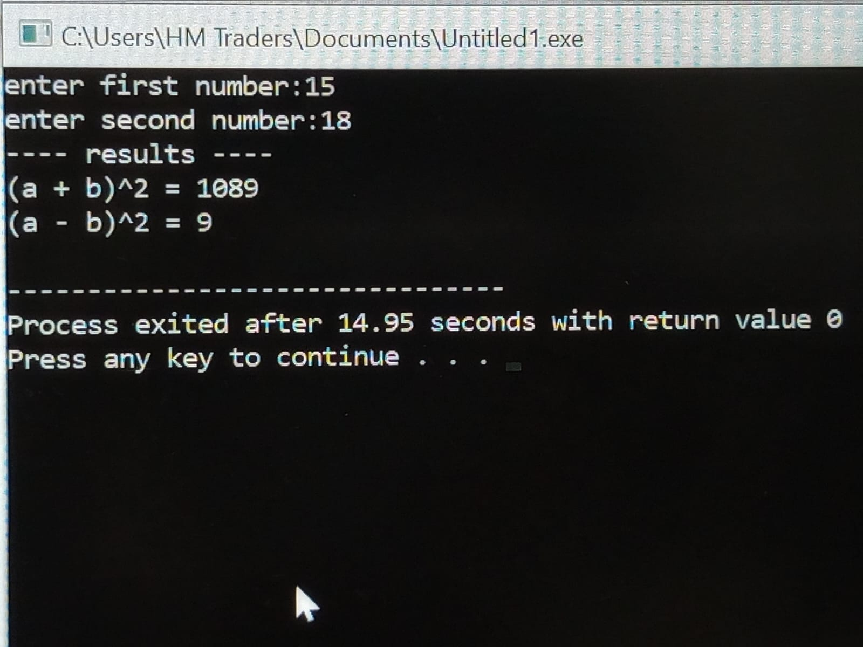

**-------- THE END-------**